**MID-TERM (IMAGE ADJUSTMENTS)**

**SUBMITTED BY: PRINCEPREET SINGH**

* **IMAGE CHOSEN FOR ADJUSTMENTS:**

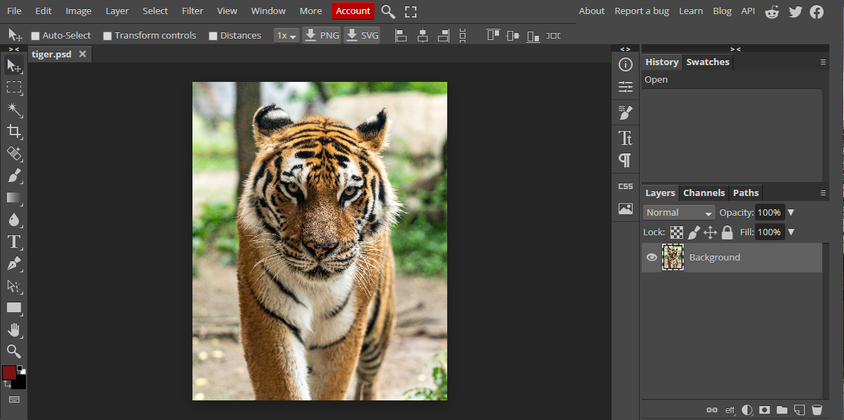

1. **CURVES:**  Following changes were observed for changing the Curves settings.

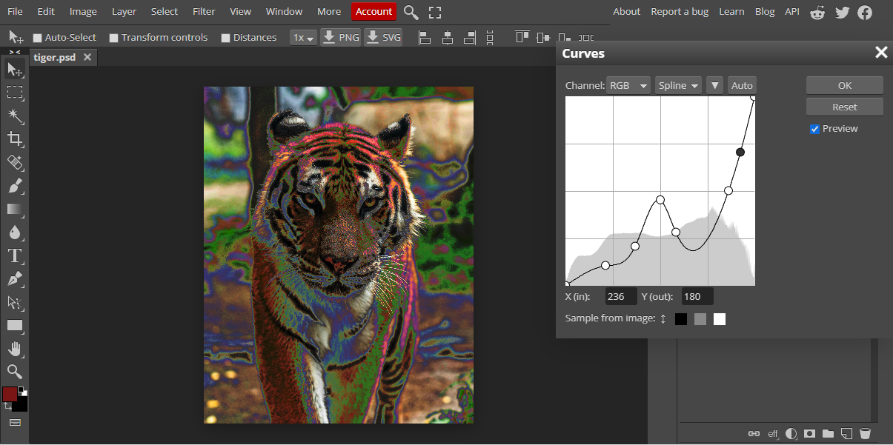

1. **Brightness/contrast**: Followings changes were observed for changing the brightness/contrast settings.

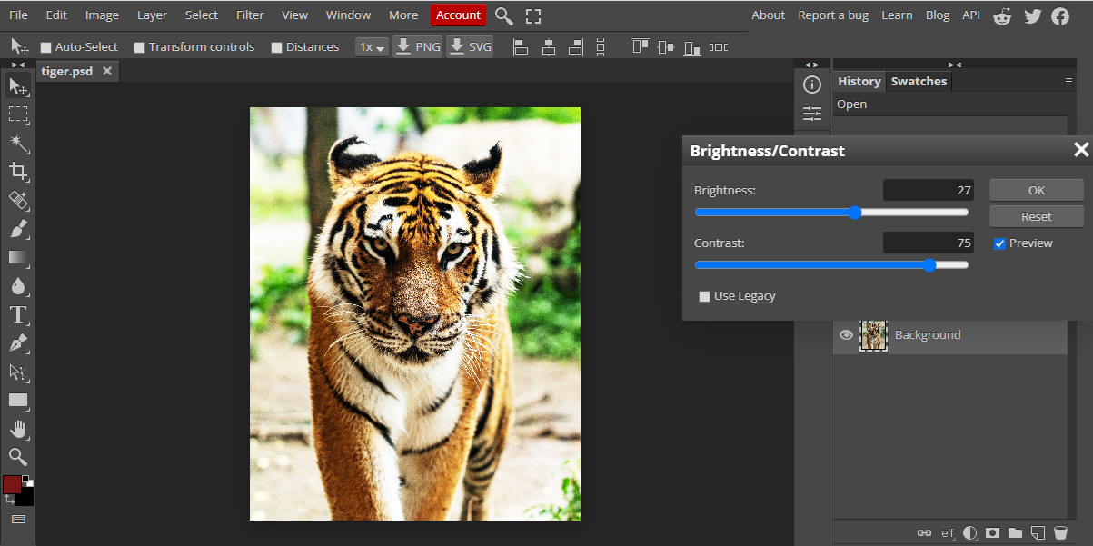

1. **LEVELS**: Following changes were observed for changing different channel settings.

* **RED:**

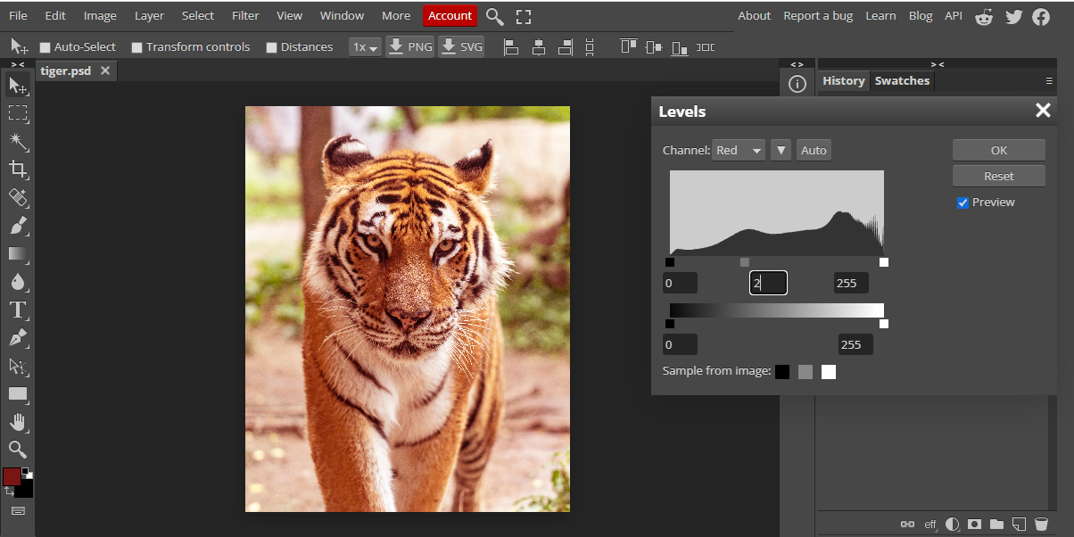

* **GREEN:**

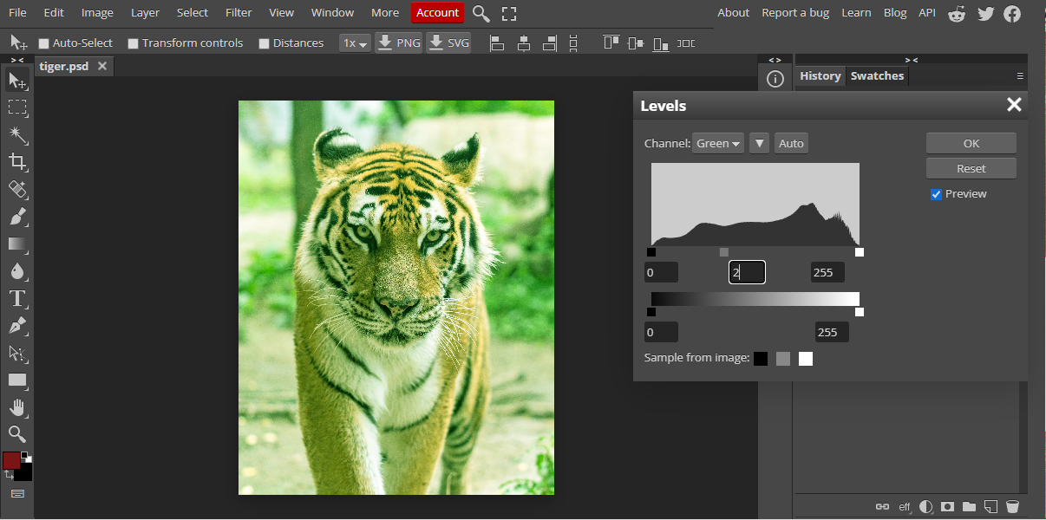

* **BLUE**

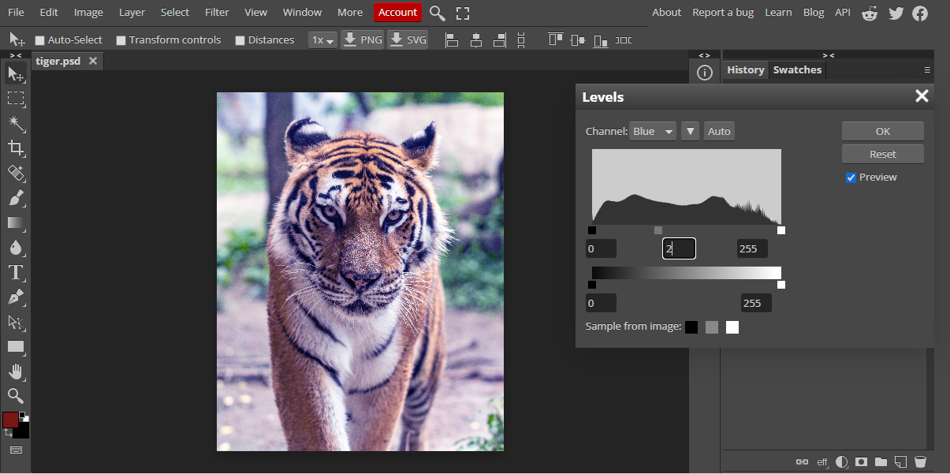

* **RGB:**

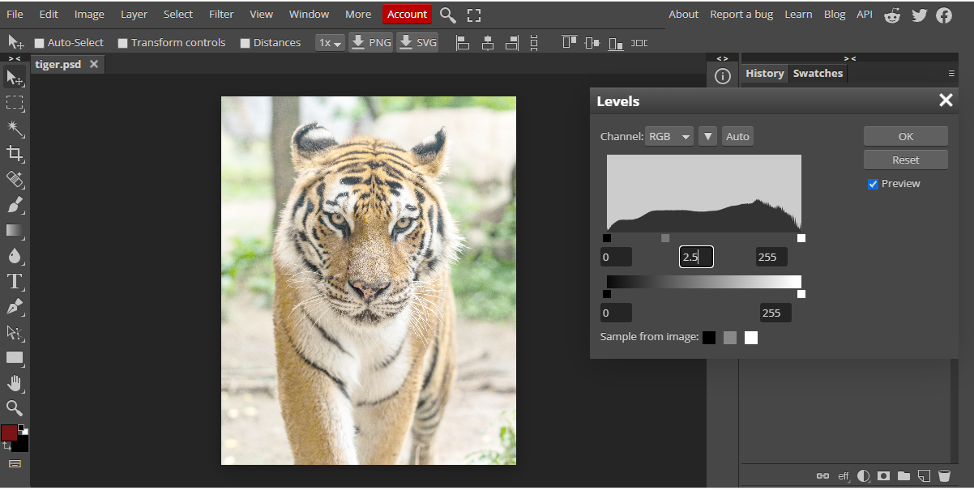

* **Algorithms:**

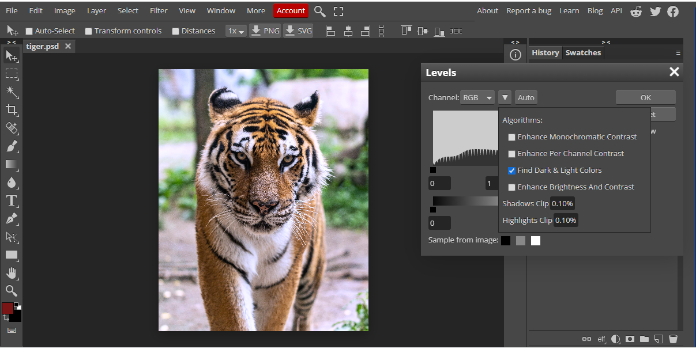

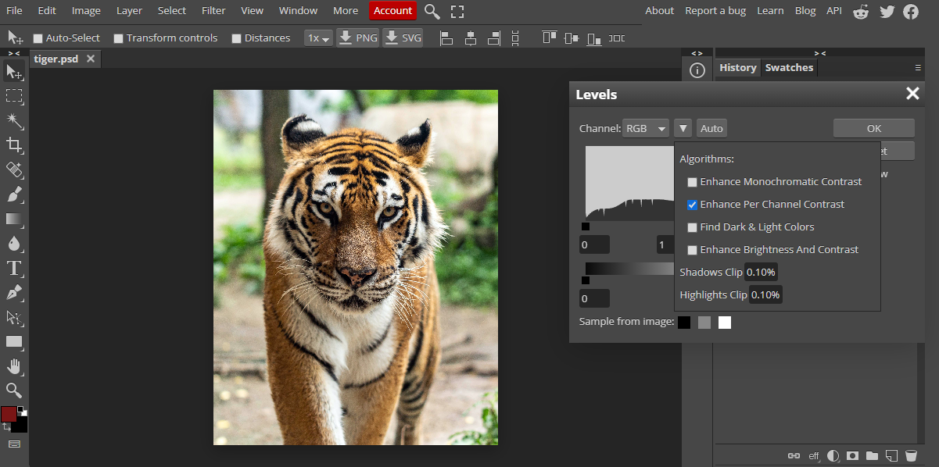

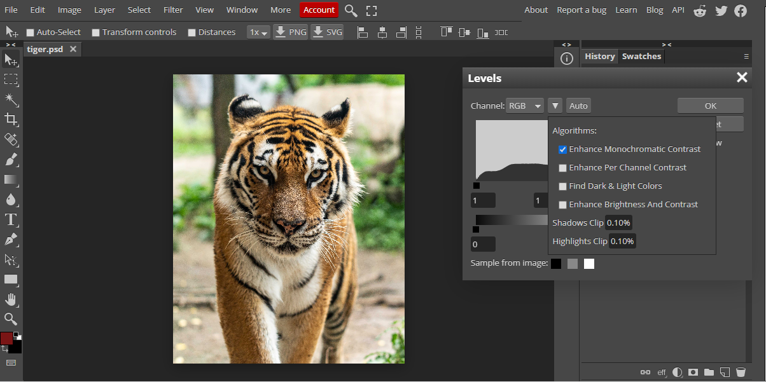

1. **BLACK AND WHITE**: Following changes were observed for changing the black and white settings.

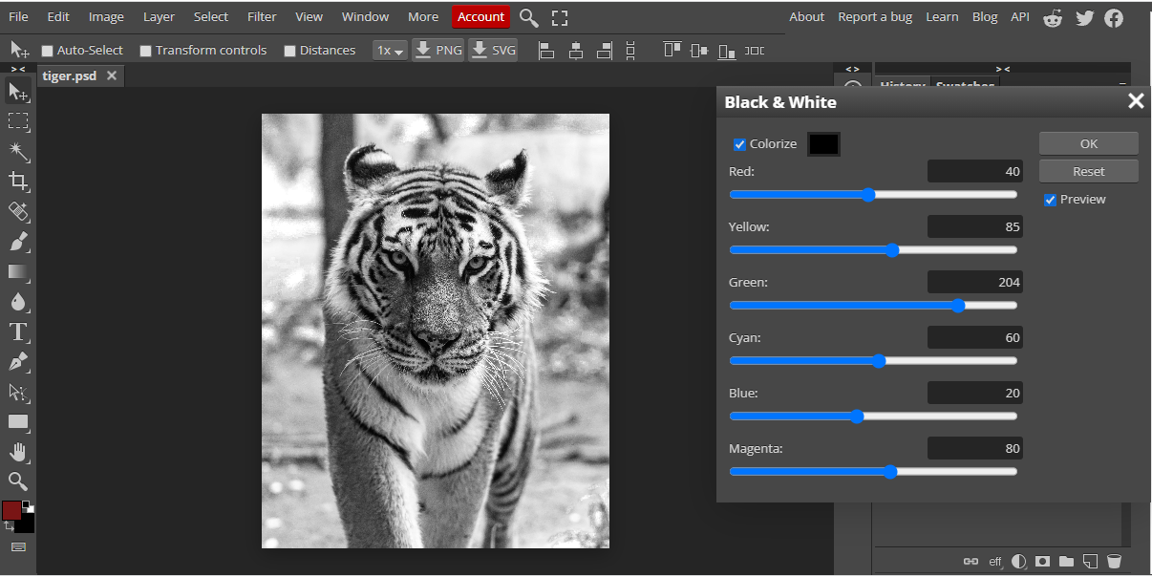

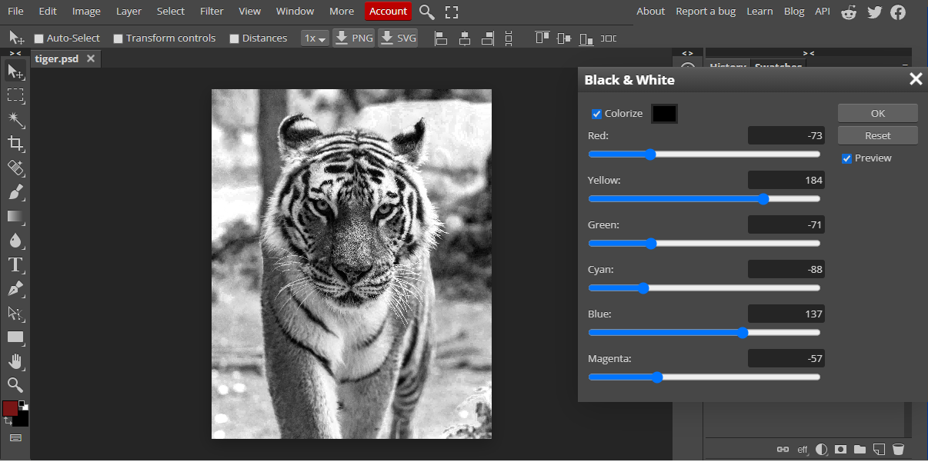

1. **HUE/SATURATION**: Followings changes were observed for setting the HUE/SATURATION.

* **MASTER:**

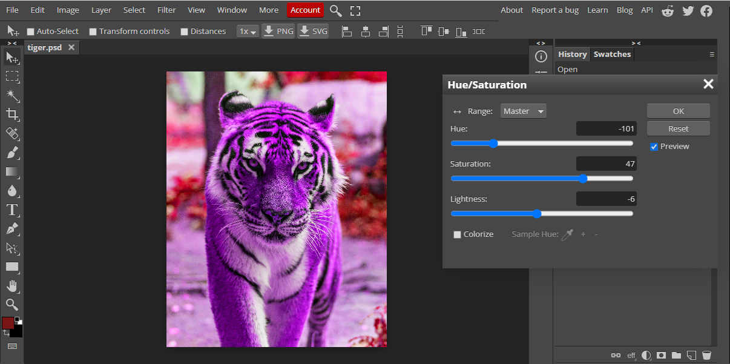

* **RED:**

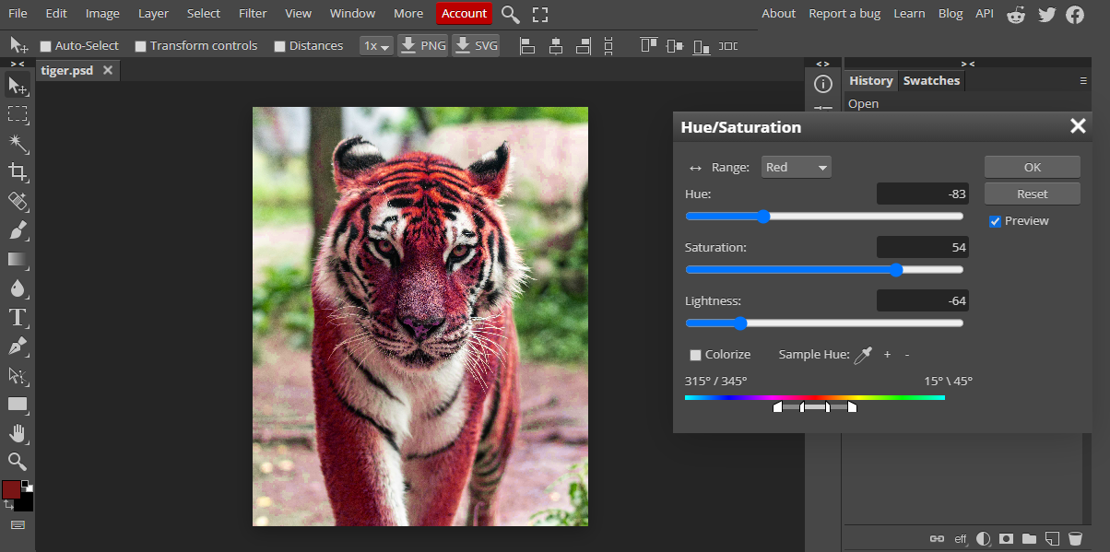

* **YELLOW:**

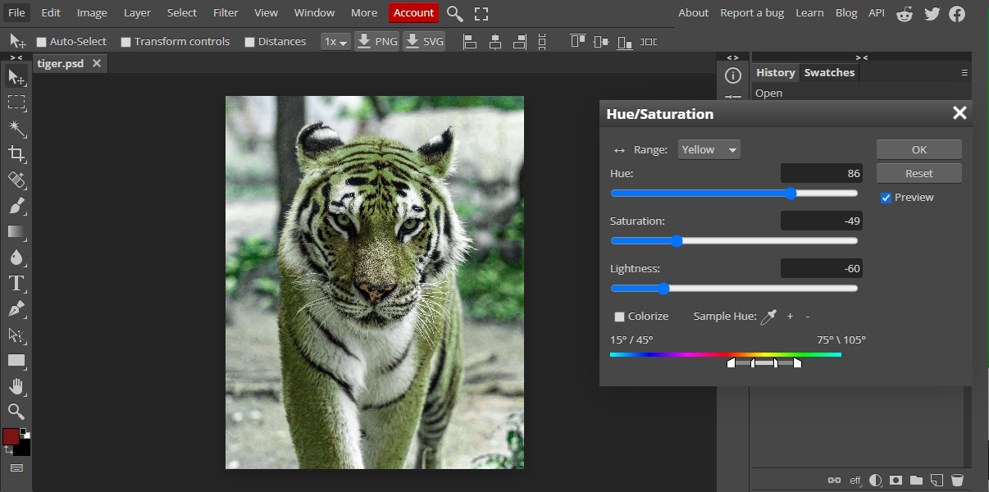

* **BLUE:**

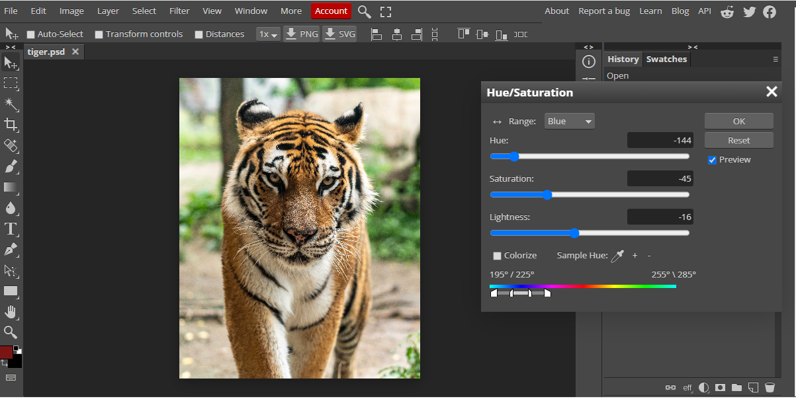

* **COLOURIZE:**

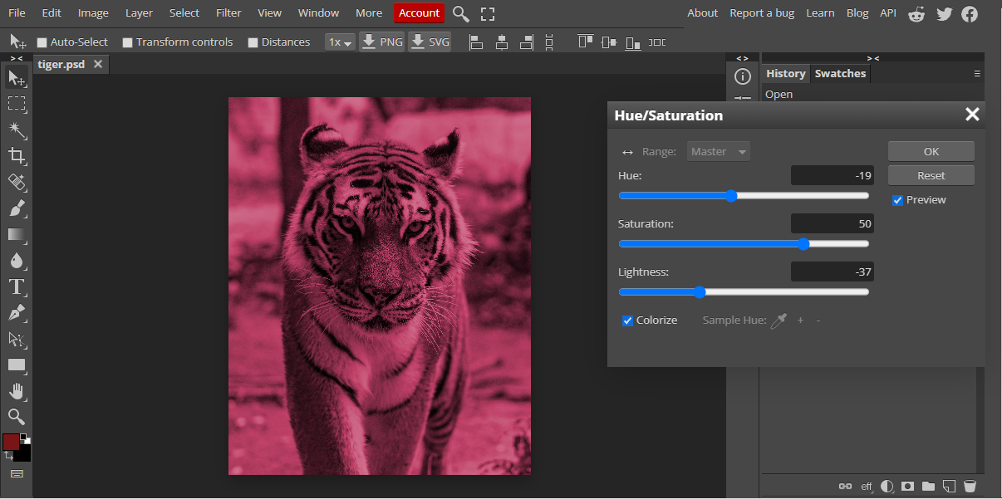

1. **VIBRANCE:** Following changes were observed for changing the Vibrance settings.

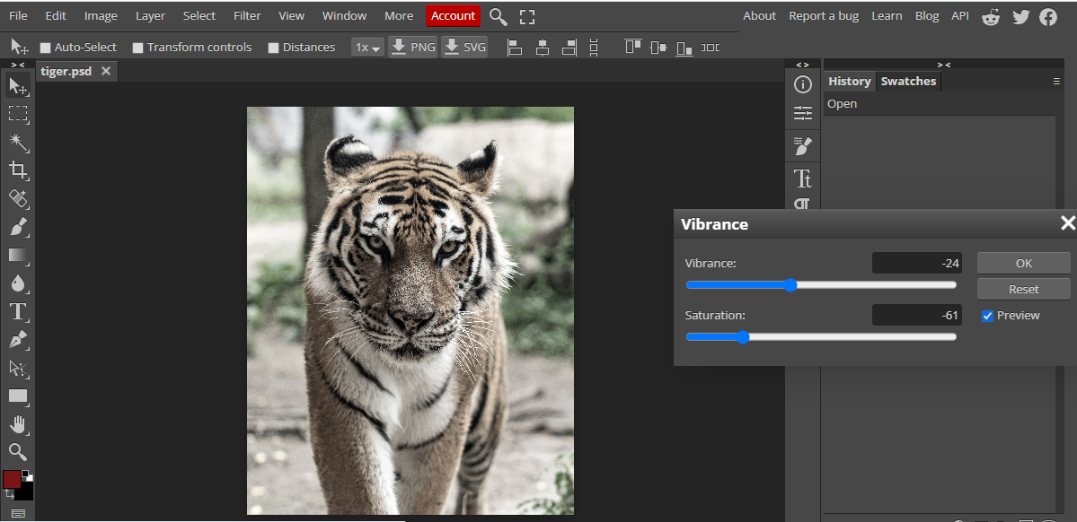

**MID-TERM (IMAGE TRANSFORMATIONS)**

* **IMAGE CHOSEN FOR ADJUSTMENTS:**

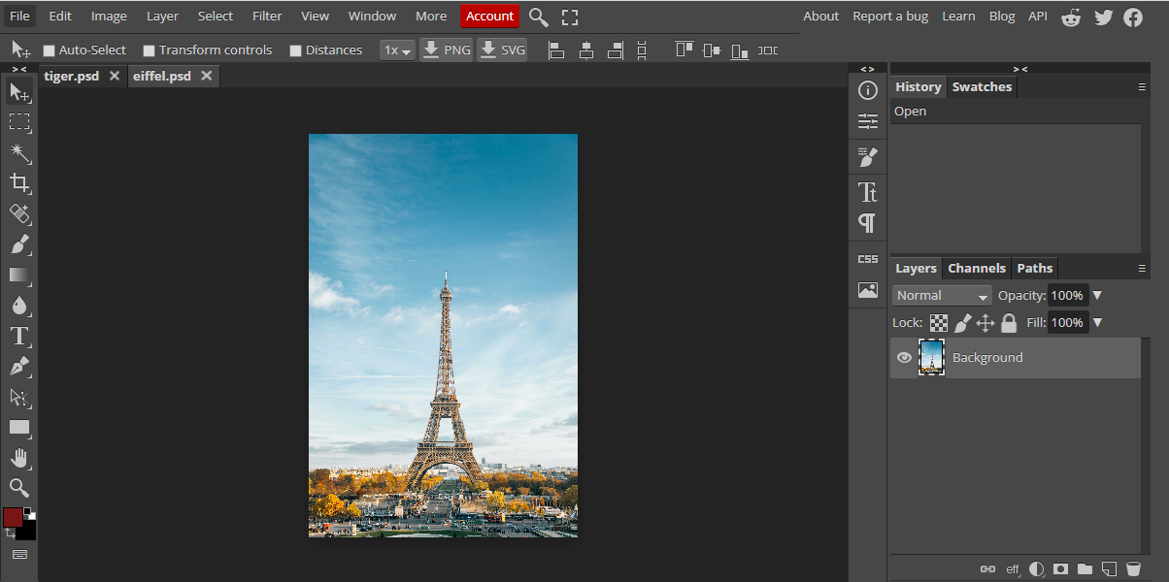

1. **90 DEGREE FLIP:**

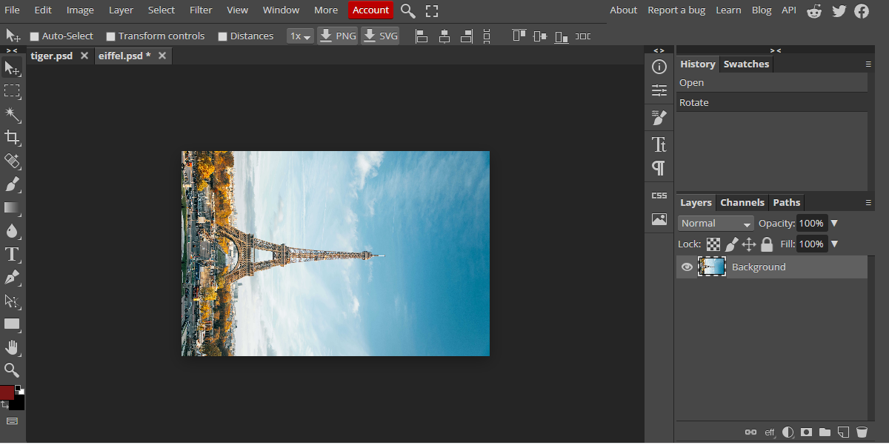

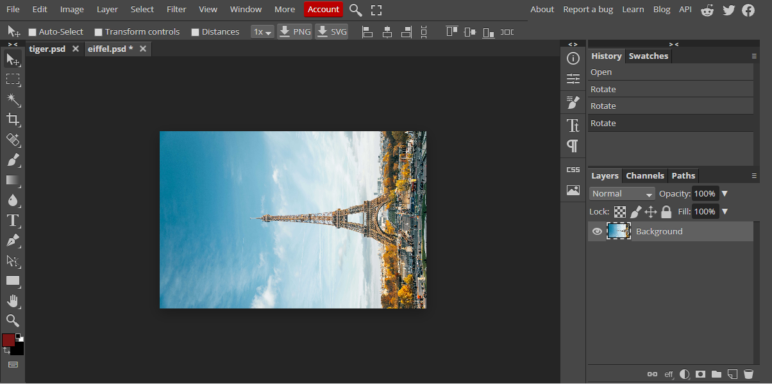

1. **180 DEGREE FLIP**

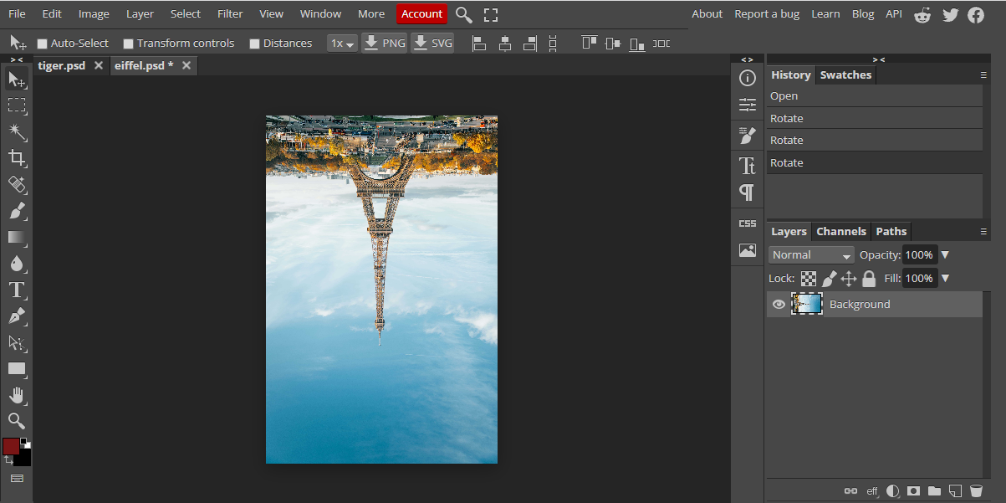

1. **HORIZONTAL FLIP:**

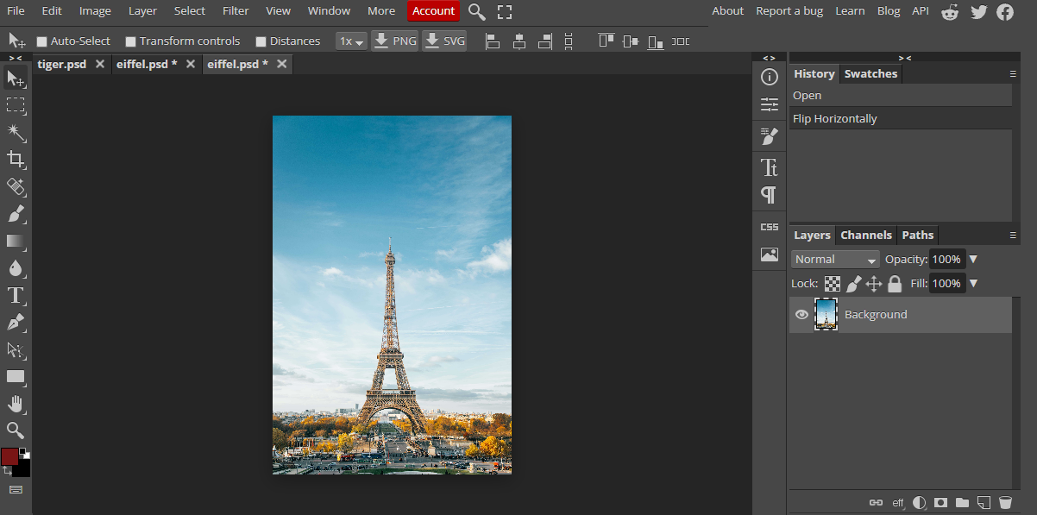

1. **VERTICAL FLIP:**

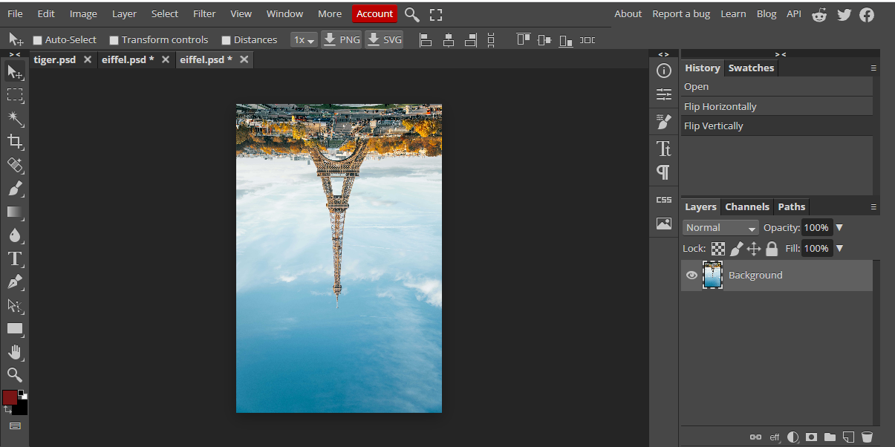

1. **DISTORT:**

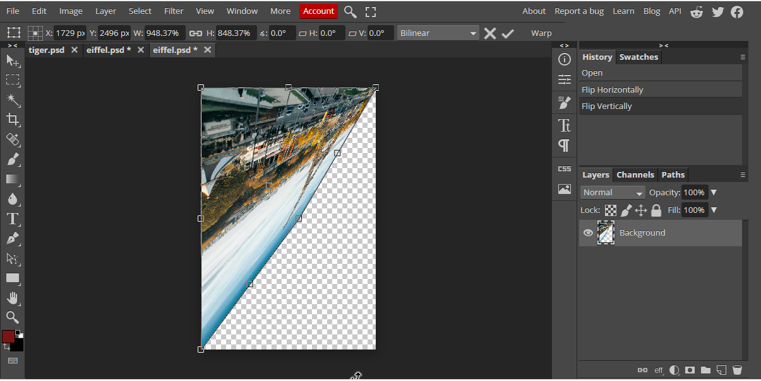

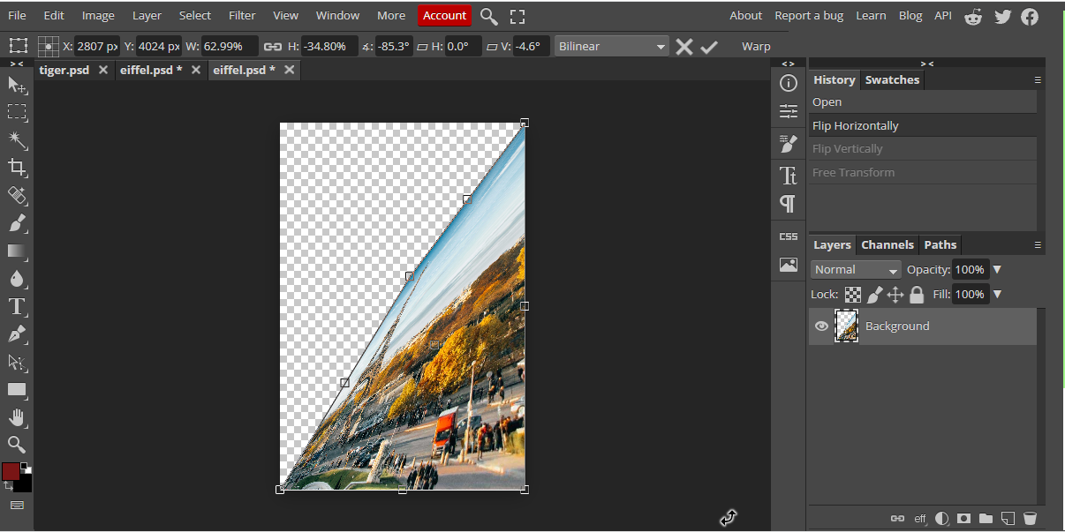

1. **WRAP:**

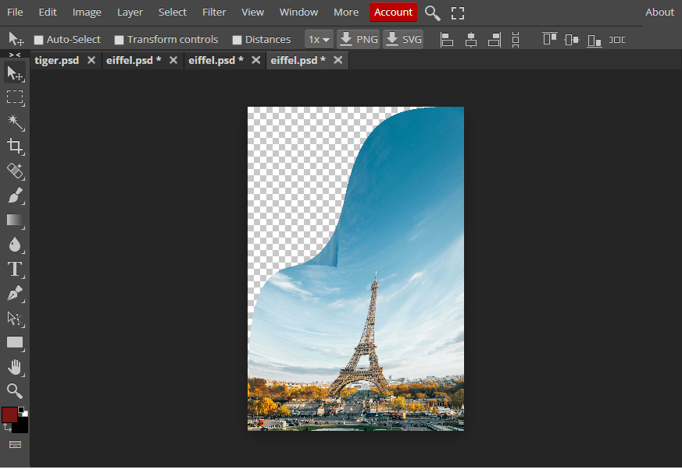

1. **PERSPECTIVE:**

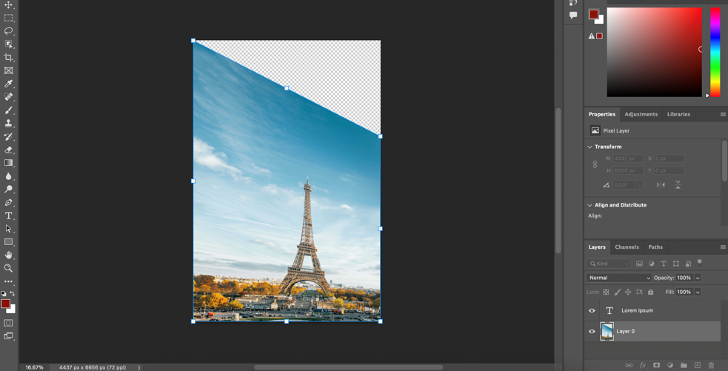

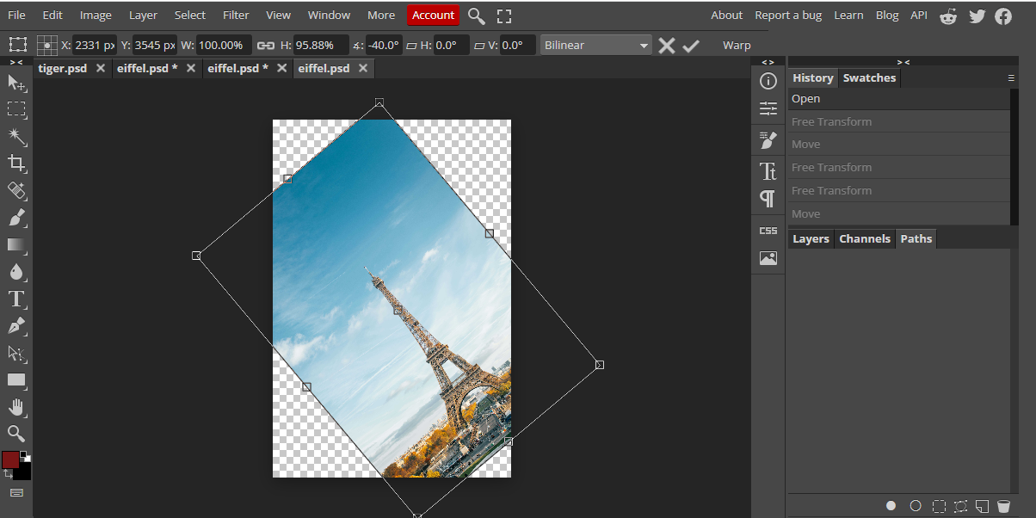

1. **SKEW:**

